Typeface

ABCDEFGHIJKLMNOPQRSTUVWXYZ

abcedfghijklmnopqrstuvwxyz

Calibri is the name of the font

Primary Logo







Color

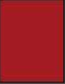

Red #A31A20

RGB Code

